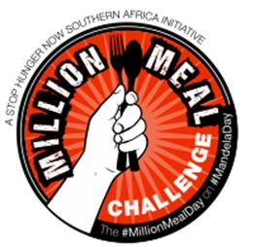
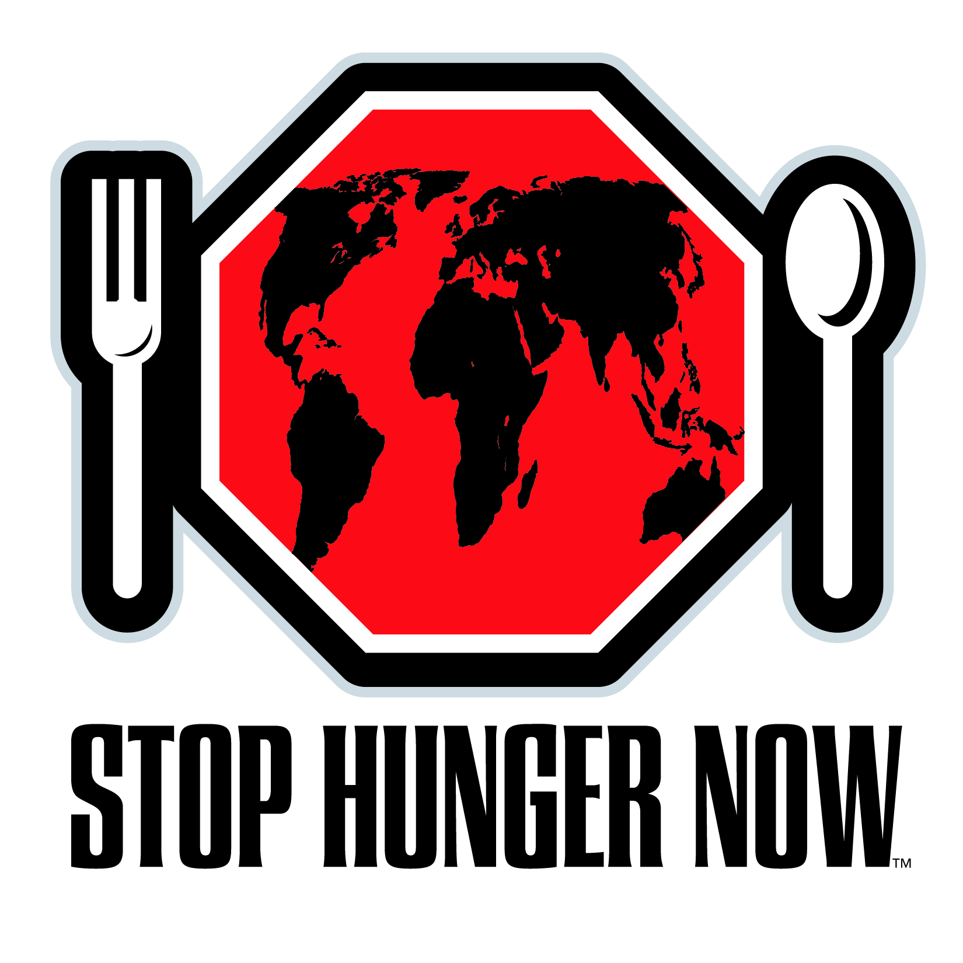
#MillionMealDay

Mandela Day Meal Packaging Event
Friday, 17 July 2015
Johannesburg ǀ Cape Town ǀ Durban
In reflection … “Meals in Memory” - 2014
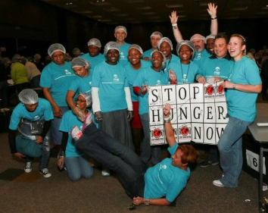
113 Companies
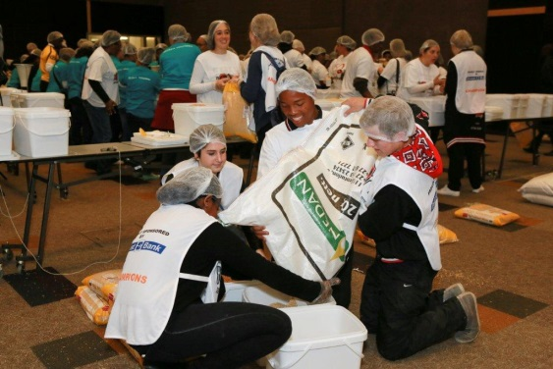
4,220 Volunteers
650,808 Meals
Many Celebrities
4,520 children
fed for an ENTIRE YEAR!

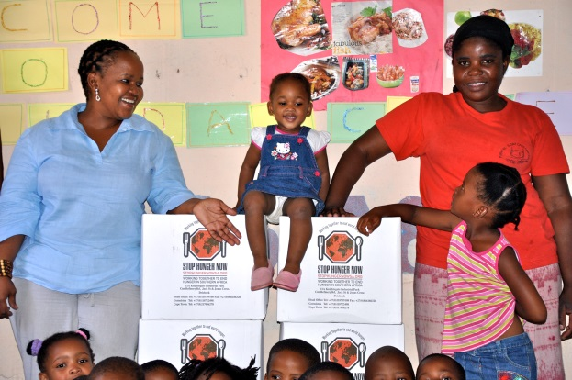
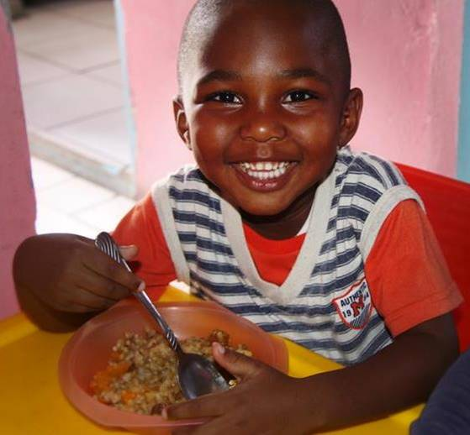

2015
2015 CALL TO ACTION
“living the legacy” means reaching higher …

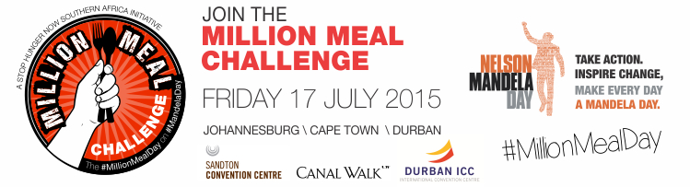

1-Million Meals Targeted – We need 400,000 more meals @R2.75 per meal – Register Your Company Now!!
3 cities – Johannesburg – Cape Town – Durban – Take up the challenge!
7,000 volunteers from an estimated 300 companies – Will you be part of this?
Packaging Meals for 67 minutes – Working together #food sustainability
Roxi Wardman (Masterchef 2014) & Elvis Blue (Idols Winner) Mrs. Graca Machel – in attendance
City | Venue
Johannesburg | Sandton Convention Centre
Cape Town | Canal Walk
Durban | Durban ICC

To register a team or find out more e-mail: events@stophungernowsa.org
or
Call our Event Co-coordinators:
Jean van Wyk - Johannesburg/Durban: 011 872 2498
Michelle Anders - Cape Town: 021 705 6278

