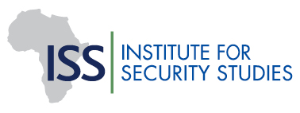 | 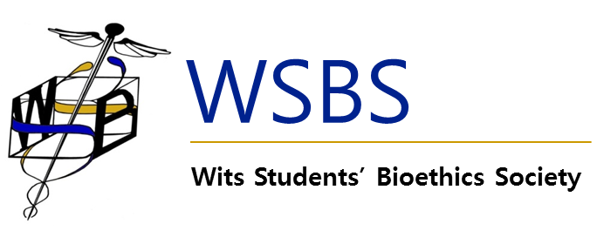 | 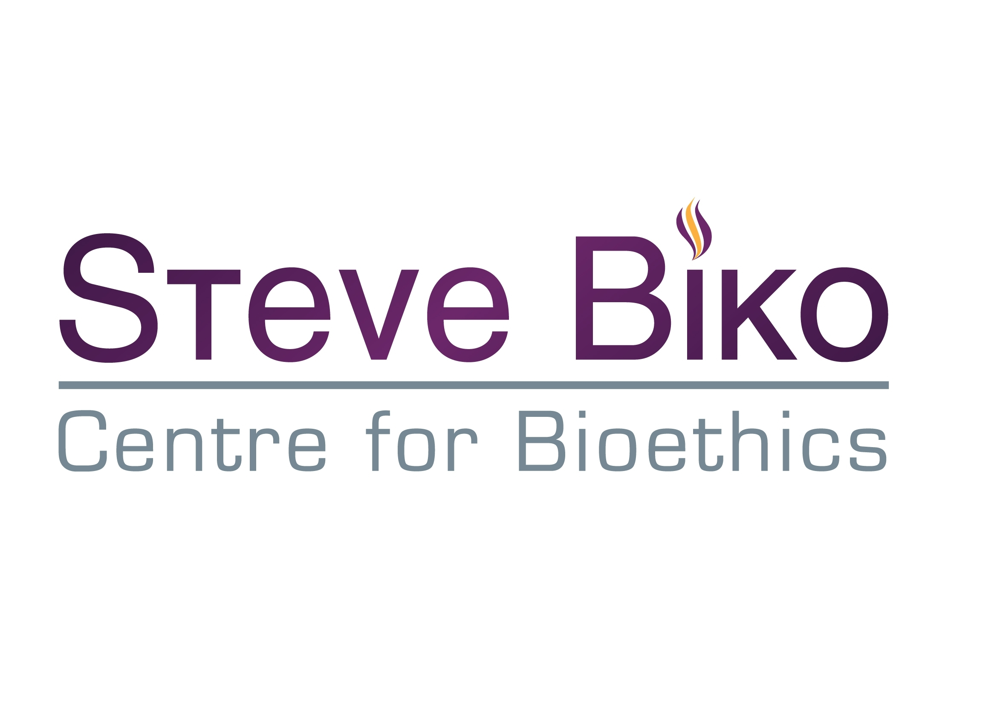 | 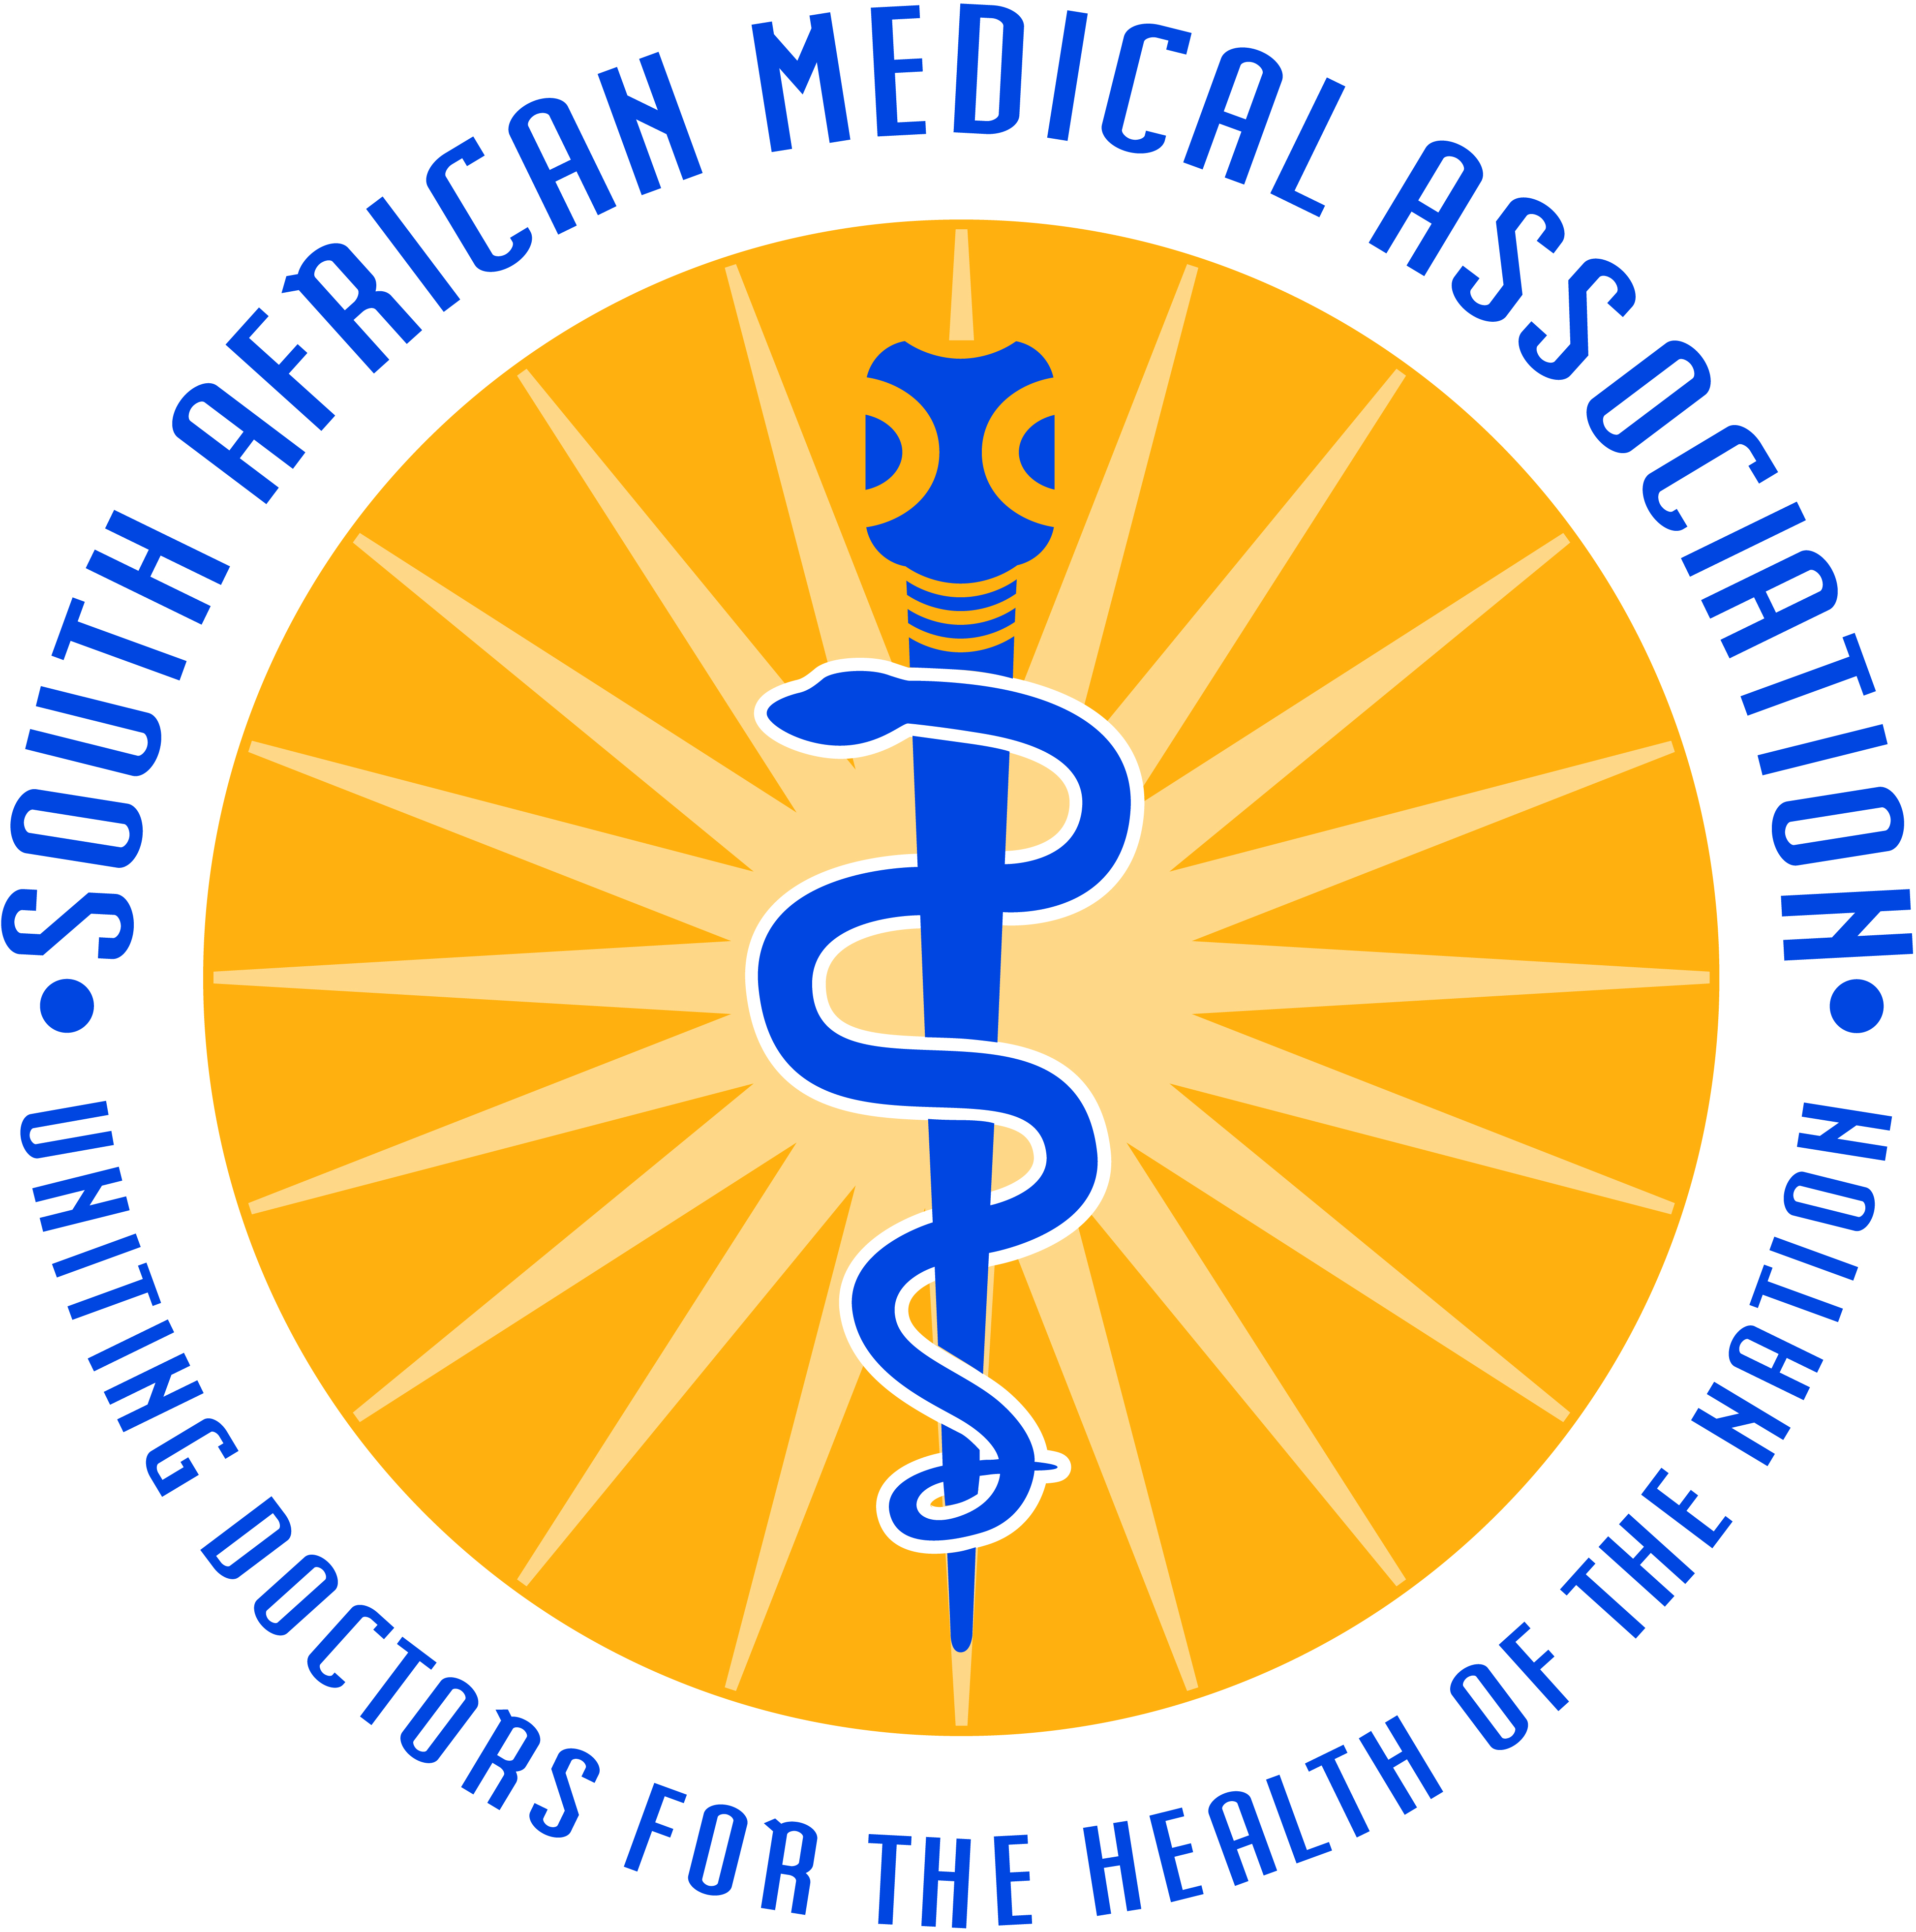

Ghosts from the past: the importance of the HPCSA's findings in the Wouter Basson case

On 26 November the Health Professions Council of South Africa (HPCSA) will begin the sentencing hearing of Dr Wouter Basson, former head of the apartheid chemical and biological weapons programme (code-named Project Coast). In December 2013 the HPCSA found Basson guilty of unethical conduct following a lengthy hearing.

The Steve Biko School of Bioethics, the South African Medical Association (Gauteng branch), the Wits Students Bioethics society and the Institute for Security Studies invite you to join us for a screening of a short film inspired by a recent visit to Roodeplaat Research Laboratories, where during apartheid scientists undertook animal experiments to, amongst other things, find toxins and chemicals that could be used to kill without leaving a trace, and where work was done to find an anti-fertility vaccine that could be administered to black women without their knowledge.

The film will be followed by a discussion about Project Coast, a reflection on the outcome of the disciplinary hearing and why this remains important today.

Date: 26 November 2014
Time: 17h00
Venue: Public Health Auditorium, School of Public Health Building
Parktown Education Campus, Wits University
Address: 27 St Andrew’s Road, Parktown, Johannesburg

Programme

17h00 | Registration and Refreshments
18h00 | Welcome and introduction: Program Chair, Professor Tawana Kupe, Deputy Vice Chancellor: Finance, University of the Witwatersrand
18h15 | Screening of ‘aka RRL’ by Kathryn Smith (with a short introduction by Smith)
18h45 | Project Coast then and now, Chandre Gould and Brian Rappert
19h20 | Ghosts of the past: The importance of remembering, Verne Harris
19h40 | Questions and discussion

Venue: Public Health Auditorium, School of Public Health Building, Parktown Education Campus, Wits University, 27 St Andrew’s Road, Parktown, Johannesburg

The talk is HPCSA accredited for 2 ethics CPD points.

Biographies of the speakers

Kathryn Smith (MA Fine Arts Wits, MSc Forensic Art, Dundee) is a multidisciplinary visual artist and curator, and senior lecturer in Visual Arts at Stellenbosch University. She produces distinctive, research-driven work that explores risk, social engagement and experimentation; and the relationship between ethics and aesthetics. Her work has been exhibited and published in over 20 countries, including the biennales of Havana and Moscow; and has been recognised by a number of awards and grants, including Chevening; the Oppenheimer Memorial Trust; the Ampersand Foundation; and the Standard Bank Award for Visual Art.Recent publications include Between Subject & Object: human remains at the interface of art and science (Michaelis Galleries, UCT) and ‘The Experimental Turn in the Visual Arts’ (in The Visual Century: South African Art in Context 1907 – 2007, Wits University Press). She is active participant in various research groups and professional organisations for forensic anthropology and human identification in South Africa and internationally.

Chandré Gould is a senior research fellow in the Governance Crime and Justice Division of the Institute for Security Studies (ISS). Between 1996 and 1999 she was in investigator and evidence analyst for the Truth and Reconciliation Commission, and was involved in the investigation of Project Coast - the chemical and biological weapons programme of the apartheid government. After 1999 she continued research into Project Coast and co-authored a monograph published by the United Nations Institute for Disarmament Research, and numerous papers and articles. She co-authored Secrets and Lies: Wouter Basson and the chemical and biological warfare programme (Zebra Press, 2002) about the trial of Dr Wouter Basson.

Brian Rappert is a Professor of Science, Technology and Public Affairs at the University of Exeter. His long term interest has been the examination of the strategic management of information; particularly in the relation to armed conflict. His books include Controlling the Weapons of War: Politics, Persuasion, and the Prohibition of Inhumanity; Biotechnology, Security and the Search for Limits; and Education and Ethics in the Life Science. More recently he has been interested in the social, ethical, and political issues associated with researching and writing about secrets, as in his book Experimental Secrets (2009) and How to Look Good in a War (2012).

Verne Harris is the Director of Research and Archive at the Nelson Mandela Foundation, he was Mandela’s archivist from 2004 to 2013. He is an honorary research fellow with the University of Cape Town, participated in a range of structures which transformed South Africa’s apartheid archival landscape, including the Truth and Reconciliation Commission, and is a former Deputy Director of the National Archives. Widely published, he is probably best-known for leading the editorial team on the best-seller Nelson Mandela: Conversations with Myself. He is the recipient of an honorary doctorate from the University of Cordoba in Argentina (2014), archival publication awards from Australia, Canada and South Africa, and both his novels were short-listed for South Africa’s M-Net Book Prize. He has served on the Boards of Archival Science, the Ahmed Kathrada Foundation, the Freedom of Expression Institute, and the South African History Archive.

