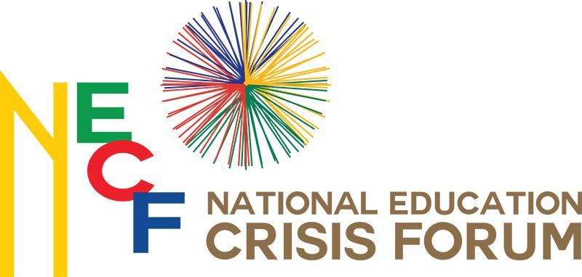

Media statement on guidelines for the provision of healthcare services during higher education protest action, and their implementation to limit violence and its effects

Date: 31 October 2017
§
From: the Nelson Mandela Foundation on behalf of the National Education Crisis Forum

The National Education Crisis Forum (the Forum) is a civil society initiative convened by Justice Dikgang Moseneke and nine co-convenors who are involved in education in South Africa, at various levels. The nine co-convenors are: Justice Yvonne Mokgoro; Archbishop Thabo Makgoba; Bishop Malusi Mpumlwana; Prof. Mary Metcalfe; Prof. Pitika Ntuli; Ms Santie Botha; Mr Sello Hatang; Mr Jabu Mabuza; and Mr Jay Naidoo.

The Forum’s primary objective is to ensure the realisation of the right to education, which is enshrined in the South African Constitution. The Forum therefore provides a platform for all parties affected by the tertiary education crisis – including civil society – to engage in dialogue, freely, openly and meaningfully. The Forum also facilitates engagements towards sustainable policy outcomes.

The Forum notes with concern the recent wave of protests at some universities, in particular the University of the Free State, the Cape Peninsula University of Technology and the University of Cape Town. Media reports and opinions from varying analyses raise expectations that protest action is likely to spread across South Africa’s universities is further cause for concern. The Forum is also deeply concerned about the violence associated with the protests. This violence is evident in media coverage of the protests.

In an effort to mitigate the consequences of any arising confrontation and its potential effects, the Forum draws the attention of the general public and all relevant stakeholders to the document, “Guidelines for the provision of healthcare services during higher education protest action”. These guidelines were developed through a consultative process convened by the Nelson Mandela Foundation from the latter part of 2016 to early 2017. Among the key stakeholders who developed the guidelines are: the South African Police Service (SAPS); university health services; student volunteer first-aid responders and security services; the Nelson Mandela Foundation; the Institute for Security Studies; and representatives from international organisations such as the International Committee of the Red Cross and Doctors without Borders.

The Forum calls on all stakeholders to ensure that all members of their respective constituencies have appropriate levels of awareness and understanding of the guidelines; implement the guidelines, as appropriate; and comply with the guidelines.

The Forum believes that violence and its effects can be significantly curtailed if all the relevant stakeholders:

- Have heightened awareness of the guidelines
- Are capacitated to appropriately understand and implement the guidelines, and
- Are required to conduct themselves in accordance with the guidelines.

It is for this reason that the Forum initiated a process of bringing the guidelines to the attention of all stakeholders in higher education.

It is vital that the public is aware of the guidelines and calls on all stakeholders, particularly universities, the police and protesting students, to comply with them during all university protest actions.

ENDS
Contact persons:
Clive Maluleke
clivem@nelsonmandela.org;
064 619 4241

Louisa Zondo
louisaz@nelsonmandela.org
083 280 5097

